
Dashboard Design

Date | 19 October 2026
Team ID | -
Project Name | Health360-Healthcare-Analytics
Maximum Marks | 5 Marks

Activity 1: Interactive and Visually Appealing Dashboards
Creating effective dashboards in Tableau Public involves presenting healthcare data through clear, interactive, and easy-to-understand visualizations. For the Health360 project, dashboards are designed to help healthcare analysts, clinical risk officers, and public health researchers explore patterns related to heart disease, diabetes, and stroke.
The dashboards aim to present important health indicators, demographic comparisons, clinical characteristics, and lifestyle-related patterns in one place. The visualizations should help users explore the dataset and identify groups that may require further investigation.

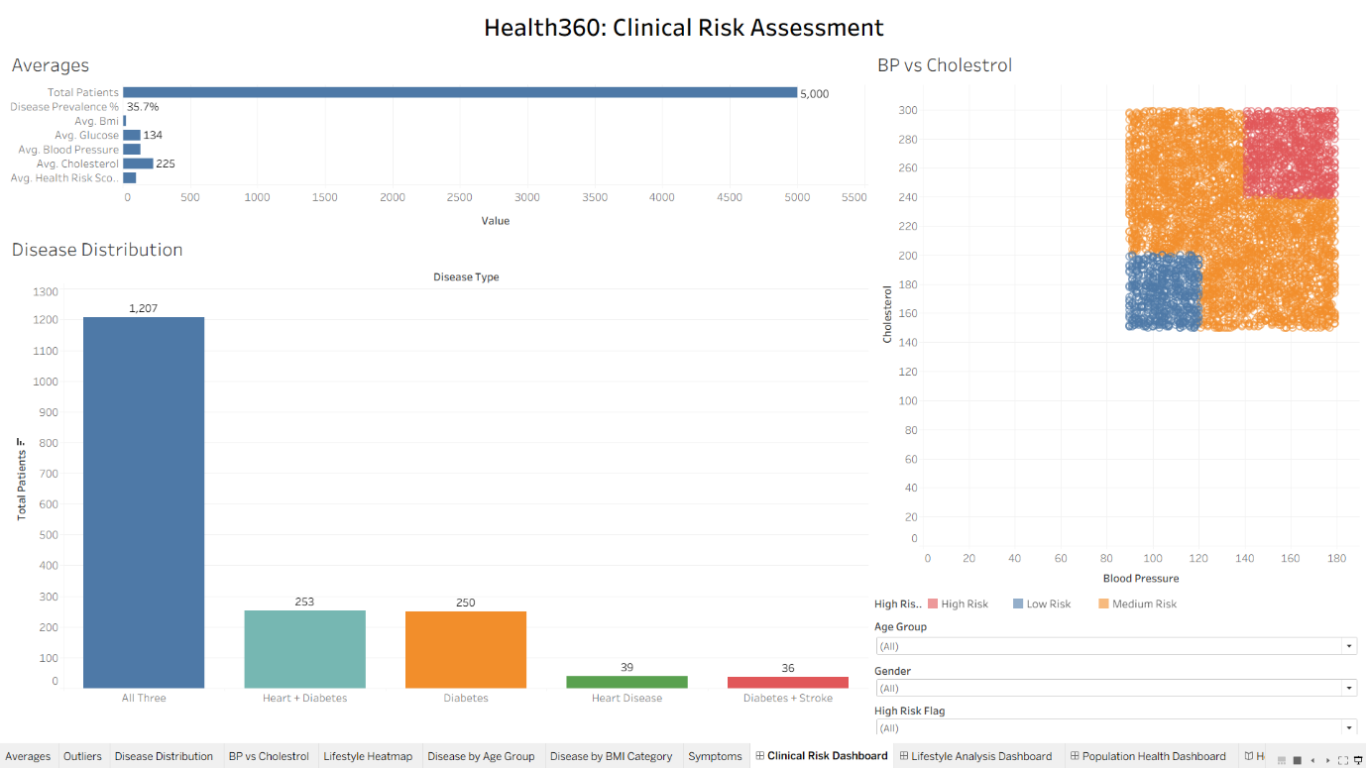

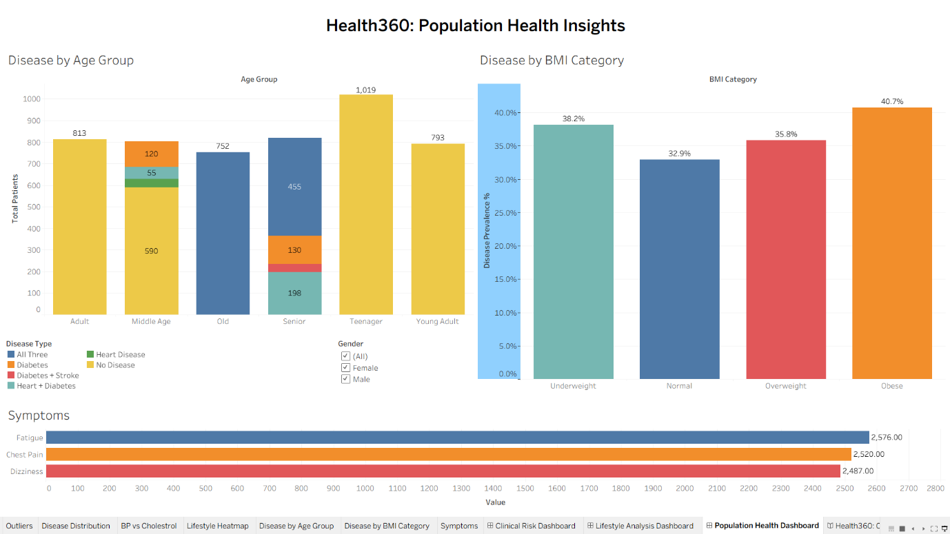

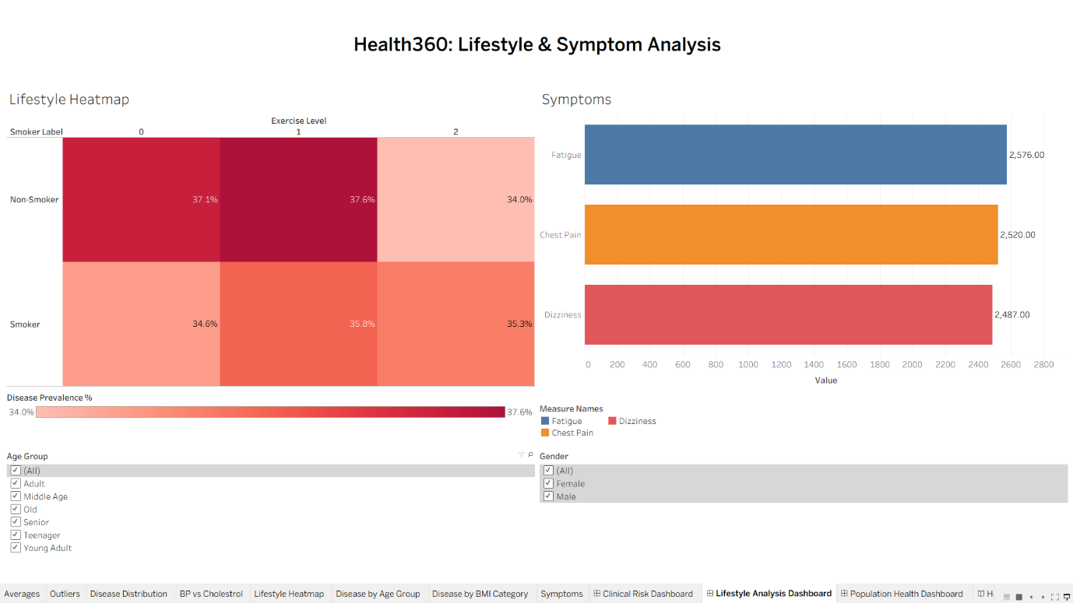

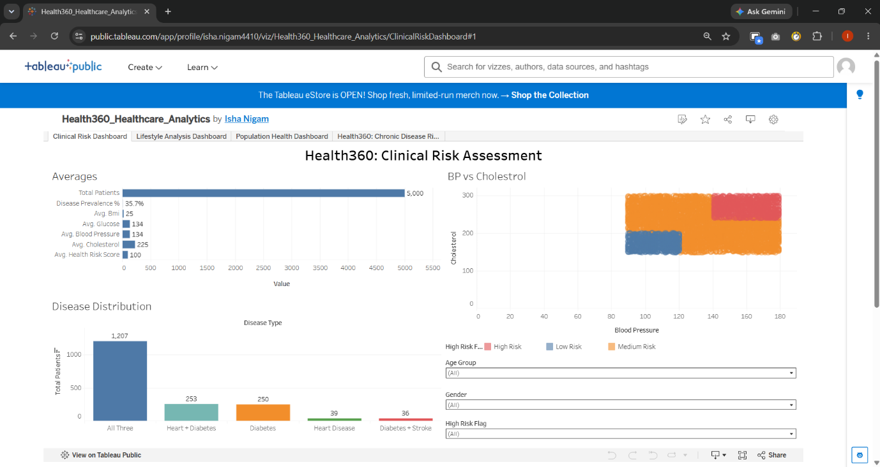

Dashboard Design Principles
- Clear and Intuitive Layout: Organize dashboards into sections for disease distribution, demographic analysis, clinical indicators, and lifestyle factors.
- Use Appropriate Visualizations: Use bar charts for disease comparisons, line charts for time-based data when available, and scatter plots or histograms for numerical clinical variables.
- Colour and Theming: Use a consistent colour palette for heart disease, diabetes, and stroke. Maintain readable labels, appropriate contrast, and clear legends.
- Interactive Filters and Slicers: Add filters for available fields, such as age group, gender, disease outcome, and other demographic or lifestyle characteristics.
- Drill-Down Capabilities: Allow users to move from overall disease distributions to specific demographic groups or categories.
- Responsive Layout: Arrange charts and dashboard elements to support easy viewing on different screen sizes.
- Custom Visuals and Icons: Use relevant titles, tooltips, symbols, and concise KPI summaries to improve readability.
- Use of Infographics: Present key statistics and findings using summary cards, highlight tables, and clearly labelled charts where appropriate.

Major Outcomes

1. Key Healthcare Indicators Are Visible in One View
The dashboard can display summary KPIs such as total records, number of positive outcomes for each disease, percentage of positive outcomes, and the number of records with missing values. These indicators provide users with an overview of the dataset.
The final KPIs should be selected according to the actual columns and values available in the healthcare CSV dataset.

2. Disease Outcomes Can Be Compared
The disease distribution charts allow users to compare recorded outcomes for heart disease, diabetes, and stroke. Bar charts and percentage summaries can help users understand how frequently each outcome appears in the dataset.
The results should be calculated from the actual dataset rather than assumed in advance.

3. Demographic Characteristics Can Be Explored
Charts can compare disease outcomes across age groups and gender, provided these fields are available. This helps users identify demographic groups with different observed outcome patterns.
These comparisons describe associations in the dataset and do not establish that age, gender, or another characteristic causes a disease.

4. Clinical Indicators Can Be Examined
Where relevant numerical fields are available, histograms, box plots, and scatter plots can be used to explore clinical measurements in relation to disease outcomes.
This analysis can help reveal distributions, differences between groups, and potential data-quality issues. Clinical interpretations should remain within the limits of the dataset.

5. Lifestyle Factors Can Be Compared With Disease Outcomes
If the dataset contains lifestyle variables, such as smoking status, physical activity, or other relevant factors, grouped or stacked bar charts can compare these characteristics across disease outcome groups.
Only variables present in the dataset should be included. The findings should be described as observed relationships, not proof of causation.

6. Interactive Filters Support Detailed Exploration
Interactive filters can allow users to focus on available demographic groups, disease outcomes, and clinical or lifestyle categories. Tableau dashboard actions, filter controls, and tooltips can help users explore specific parts of the data.
A reset option can be provided where supported by the dashboard design, allowing users to return to the default view.

Design Features
- Layout: Place KPI summary cards at the top, followed by disease distribution, demographic comparisons, clinical indicators, and lifestyle analysis.
- Visualizations: Use bar charts, histograms, box plots, scatter plots, and highlight tables according to the available data.
- Colour and Theming: Apply a consistent colour scheme, with accessible contrast and clear visual distinctions between disease outcomes.
- Interactivity: Use Tableau filters, dashboard actions, and tooltips to support exploration.
- Data Accuracy: Validate calculated fields, denominators, null values, and category labels before presenting findings.
- Documentation: Include dashboard screenshots and explain the purpose of each visualization in the project report.

Overall Outcome
The Health360 dashboard provides a consolidated view of disease outcomes, demographic characteristics, and available clinical and lifestyle indicators. It enables users to explore healthcare data interactively, compare groups, and identify patterns that may warrant further analysis.
The dashboard is intended for exploratory analysis and educational purposes. It does not provide medical diagnoses, establish causal relationships, or replace professional clinical assessment.

